TENDER SPECIFICATION

DIRIS Digiware

Multi-circuit power and residual current monitoring system for electrical installations

Purpose of the specification
This specification describes a multi-function, multi-circuit measurement system with associated current sensors designed for measuring, monitoring and managing electrical energy within an electrical installation.

The technical benchmark reference is SOCOMEC DIRIS Digiware or a similar solution that has been approved by us.

- General characteristics

The multi-function measurement system shall be CE-marked, UL-listed and be a compact modular multi-circuit PMD* compliant with IEC standard 61557-12.

The Plug & Play system shall be based on modules that can be interconnected without tools. It shall automatically detect the type of network, circuit and current sensor rating, shall check the current flow direction, and automatically detect and assign a Modbus address to the connected modules.
The measurement system will accept a maximum of 32 modules, allow to monitor a large number of circuits.

The system comprises the following:
- A 24VDC power supply for the entire system.
- A system interface to centralise and communicate measurement data via RS485 or Ethernet over multiple communication protocols, and to display measurements locally or on a web-based interface.
- A single voltage measurement module for the entire system,
- One or multiple current measurement modules.
These modules must have integrated current sensors to measure circuits of up to 120 A or must be connected to external current sensors via an RJ connection to measure circuits of higher currents.
The current measurement modules will have up to 6 independent current inputs to simultaneously measure several types of circuit (three-phase, single-phase, etc.).
- One or multiple residual current monitoring (RCM) modules
RCM modules shall combine power monitoring and residual current monitoring functions by connecting to external current sensors for power monitoring purposes and residual current transformers to monitor residual currents (I_{Δ} and I_{PE}).
The connection to current sensors or residual CTs is made using dedicated colour coded RJ12 cables to avoid wiring errors.
The RCM module shall have a minimum of 6 independent inputs to measure several types of circuits (three-phase, single-phase etc.).
- Optional Input/Output modules.
- Environmental Bluetooth sensors

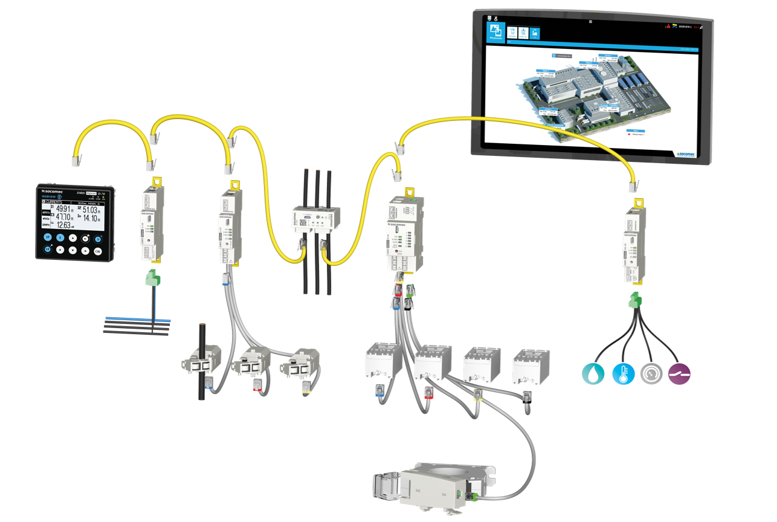

An RJ45 bus shall interconnect the modules. This bus distributes the 24 VDC power supply and communication to all modules and synchronises the single voltage measurement with the current measurements for all circuits. This technology consolidates the voltage measurement at a single point.

All modules can be fitted on a DIN rail or back plate.

Associating the measurement modules with current sensors will guarantee a global accuracy class 0.5 for the global measurement chain (measurement module and current sensors) for the active power (kW) according to IEC 61557-12 from 2 to 120% of the rated current

*PMD: Power Metering and Monitoring Device in accordance with IEC 61557-12.

- Components of the power monitoring system

  - Communication and power supply interfaces C-31, M-50, M-70, D-50, D-70

- Interface module: DIRIS Digiware C-31: RS485 Modbus RTU version
The module shall have the following characteristics:
- A 24 VDC power supply
- DIN rail mounting
- An RS485 port for Modbus RTU communication

- DIRIS Digiware M-50 & DIRIS Digiware M-50 Bluetooth gateway: RS485/Ethernet – Multi-protocol version
The gateway shall have the following characteristics
- A 24 VDC power supply
- An internal battery to ensure that the date and time of the complete measurement system is not reset after an outage.
- DIN rail mounting
- RS485 port for Modbus RTU communication and Ethernet port for Modbus TCP, BACnet IP, SNMPv1, v2, v3, Traps
- SNTP time-synchronisation
- Email notifications in the event of an alarm (SMTP/SMTPS)
- Embedded webserver WEB-CONFIG for configuration of communication settings of the system
- Integrated Cyber-security
- Associate Bluetooth sensors with the M-50 Bluetooth version

- DIRIS Digiware M-70 & DIRIS Digiware M-70 Bluetooth gateway: RS485/Ethernet – Multi-protocol version with web-visualisation WEBVIEW-M
The gateway shall have the following characteristics
- A 24 VDC power supply
- An internal battery to ensure that the date and time of the complete measurement system is not reset after an outage.
- DIN rail mounting
- RS485 port for Modbus RTU communication and Ethernet port for Modbus TCP, BACnet IP, SNMPv1, v2, v3, Traps
- SNTP time-synchronisation
- Email notifications in the event of an alarm (SMTP/SMTPS)
- Embedded web software to remotely display data from an internet browser
- Integrated Cyber-security
- Associate Bluetooth sensors with the M-70 Bluetooth version

- Display DIRIS Digiware D-50 & DIRIS Digiware D-50 Bluetooth: RS485/Ethernet – Multi-protocol version
The display shall have the following characteristics:
- A 24 VDC power supply to avoid dangerous voltages on panel doors
- An internal battery to ensure that the date and time of the complete measurement system is not reset after an outage.
- A high-resolution graphic display
- 10 keys for direct access to measurement data, circuit selection and device settings
- IP65 degree of protection for the front panel
- RS485 port for Modbus RTU communication and Ethernet port for Modbus TCP, BACnet IP, SNMPv1, v2, v3, Traps
- SNTP time-synchronisation
- Email notifications in the event of an alarm (SMTP/SMTPS)
- Embedded webserver WEB-CONFIG to configure the system’s communication settings
- Integrated Cyber-security
- Associate Bluetooth sensors for the D-50 Bluetooth version

- Display DIRIS Digiware D-70 & DIRIS Digiware D-70 Bluetooth: multi-protocol RS485/Ethernet + Webserver embedded
The display shall have the following characteristics:
- A 24 VDC power supply to avoid dangerous voltages on panel doors
- An internal battery to ensure that the date and time of the complete measurement system is not reset after an outage.
- A high-resolution graphic display
- 10 keys for direct access to measurement data, circuit selection and device settings
- IP65 degree of protection for the front panel
- RS485 port for Modbus RTU communication and Ethernet port for Modbus TCP, BACnet IP, SNMPv1, v2, v3, Traps
- Embedded web software to remotely display data from an internet browser
- SNTP time-synchronisation
- Email notifications in the event of an alarm (SMTP/SMTPS)
- Integrated Cyber-security
- Associate Bluetooth sensors for the D-70 Bluetooth version

WEB-CONFIG is embedded to the M-50 gateway / D-50 display and shall:
- Be reachable from any web browser
- Allow the configuration of communication settings
- integrate cyber-security features (TLS/SSL certificates, firewall, restriction or deactivation of specific peripherals/, ports or services)
- Allow to automatically export data via FTP(S)

WEBVIEW-M is embedded to the M-70 gateway / D-70 display and shall:
- Be reachable by multiple users from any web browser without any licence fees
- Allow the configuration of communication settings
- Integrate cyber-security features (TLS/SSL certificates, firewall, restriction or deactivation of specific peripherals/, ports or services)
- Allow to automatically export data via FTP(S)
- Display real-time and logged measurement data
- Display on-going alarms and keep a log of finished alarms
- Allow a manual export of measurement data over a specific time period

  - DIRIS Digiware U-xx, voltage measurement modules

- DIRIS Digiware U-10: metering
The voltage measurement module shall measure the following parameters in real-time values:
- Voltages V1, V2, V3, U12, U23, U31
- Frequency F

The module shall also include the following alerts:
- System alarm (incorrect phase rotation)
- Dedicated timestamped MID alarms :
- Intentional configuration change :
Electrical network, Nominal frequency, Voltage transformer, Date/time
- Physical tampering :
U-10 module swap, Power Cycle, Digiware bus alteration
- MID CRC periodic check failure (accidental changes) :
Software ID, Calibration values, Energies, Legal parameters

- DIRIS Digiware U-30: analysis
The voltage measurement module shall measure the following parameters in real-time values, average values, min/max timestamped real-time values, min/max timestamped averages:
- Voltages V1, V2, V3, U12, U23, U31, Usystem, Vsystem (average of the 3 phases)
- Frequency F
- THD V1, V2, V3, U12, U23, U31, system (average of the 3 phases)
- Individual harmonics U and V up 63rd
- Unbalance of Ph-N and Ph-Ph voltages with direct, inverse and zero-sequence symmetrical components
- Power quality events (swells, dips and interruptions) according to EN 50160 based on a half-cycle sampling rate (10 ms at 50 Hz)

The module shall also include the following alarms:
- System alarm (incorrect phase rotation)
- Timestamped alarms for real-time or average values based on the above electrical parameters
- Boolean combination of alarms
- Dedicated timestamped MID alarms :
- Intentional configuration change :
Electrical network, Nominal frequency, Voltage transformer, Date/time
- Physical tampering :
U-30 module swap, Power Cycle, Digiware bus alteration
- MID CRC periodic check failure (accidental changes) :
Software ID, Calibration values, Energies, Legal parameters

  - DIRIS Digiware S-xx / I-xx / BCM-xx current measurement modules

There are several types of module that can be added to the power monitoring system:

- Metering
  - DIRIS Digiware S-130 & DIRIS Digiware S-130MID: all-in-one with 3 built-in sensors up to 63 A
The module shall measure the following real-time parameters:
- I1, I2, I3, IN,
- Partial and total energies: ± kWh, ± kvarh (leading and lagging), kVAh
- ∑P, ∑Q, ∑S, ∑PF

The module shall also include the following alarms:
- System alarms for incorrect voltage/current association indicating a possible wiring error
- Dedicated timestamped MID alarms for the DIRIS Digiware S-130MID :
- Intentional configuration change :
Load status intentional change, Load name intentional change, Load type intentional change, CT orientation intentional change, CT associated voltage intentional change, Date/time intentional change
- Physical tampering :
Power Cycle, Digiware bus alteration
- MID CRC periodic check failure (accidental changes) :
Software ID, Calibration values, Energies, Legal parameters

The module shall also offer advanced technologies based on a voltage detection of conductors, enabling to:
- Monitor the upstream protective device (ON/OFF position, tripping, operation and trip counters) without the use of auxiliary contacts. This function will be compatible with any brand and any type of protective device.
- Provide a software correction of wiring errors, even off-load, by pressing the button on the front of the current measurement module.

  - DIRIS Digiware I-30 & DIRIS Digiware I-30MID: 3 current inputs
The module shall measure the following real-time parameters:
- I1, I2, I3, IN,
- Partial and total energies: ± kWh, ± kvarh (leading and lagging), kVAh
- ∑P, ∑Q, ∑S, ∑PF

The module shall also include the following alerts:
- System alarms (sensor disconnected, wrong V/I association, wrong CT primary)
- Dedicated timestamped MID alarms for the DIRIS Digiware I-30MID :
- Intentional configuration change :
Load status intentional change, Load name intentional change, Load type intentional change, CT rating intentional change, CT orientation intentional change, CT associated voltage intentional change, Date/time intentional change, inconsistent CT, CT disconnection,
- Physical tampering :
Power Cycle, Digiware bus alteration
- MID CRC periodic check failure (accidental changes) :
Software ID, Calibration values, Energies, Legal parameters

  - DIRIS Digiware I-60 & DIRIS Digiware I-60MID: 6 current inputs
The module shall measure the following real-time parameters:
- I1, I2, I3, IN,
- Partial and total energies: ± kWh, ± kvarh (leading and lagging), kVAh
- ∑P, ∑Q, ∑S, ∑PF

The module shall also include the following alarms:
- System alarms (sensor disconnected, wrong V/I association, wrong CT primary)
- Dedicated timestamped MID alarms for the DIRIS Digiware I-60MID :
- Intentional configuration change :
Load status intentional change, Load name intentional change, Load type intentional change, CT rating intentional change, CT orientation intentional change, CT associated voltage intentional change, Date/time intentional change, inconsistent CT, CT disconnection,
- Physical tampering :
Power Cycle, Digiware bus alteration
- MID CRC periodic check failure (accidental changes) :
Software ID, Calibration values, Energies, Legal parameters

- Metering and load curves
  - DIRIS Digiware I-31: 3 current inputs
The module shall measure the following real-time parameters:
- I1, I2, I3, IN,
- Partial and total energies: ± kWh, ± kvarh (leading and lagging), kVAh
- Max. 8 configurable tariffs
- ∑P, ∑Q, ∑S, ∑PF
- P,Q,S, PF per phase
- P+/P-, Q+/Q-, S load curves (15-min demand power)

The module shall also include the following alarms:
- System alarms (sensor disconnected, wrong V/I association, wrong CT primary)
- Measurement alarm on Ptot and Stot (Total power)

  - DIRIS Digiware I-61 & DIRIS Digiware I-61MID: 6 current inputs
The module shall measure the following real-time parameters:
- I1, I2, I3, IN,
- Partial and total energies: ± kWh, ± kvarh (leading and lagging), kVAh
- Max. 8 configurable tariffs
- ∑P, ∑Q, ∑S, ∑PF
- P,Q,S, PF per phase
- P+/P-, Q+/Q-, S load curves (15-min demand power)

The module shall also include the following alarms:
- System alarms (sensor disconnected, wrong V/I association, wrong CT primary)
- Measurement alarm on Ptot and Stot (Total power)
- Dedicated timestamped MID alarms for the DIRIS Digiware I-61MID :
- Intentional configuration change :
Load status intentional change, Load name intentional change, Load type intentional change, CT rating intentional change, CT orientation intentional change, CT associated voltage intentional change, Date/time intentional change, inconsistent CT, CT disconnection,
- Physical tampering :
Power Cycle, Digiware bus alteration
- MID CRC periodic check failure (accidental changes) :
Software ID, Calibration values, Energies, Legal parameters

- Monitoring
  - DIRIS Digiware I-43: 4 current inputs
The module shall measure the following real-time parameters:
- I1, I2, I3, IN (measured)
- Partial and total energies: ± kWh, ± kvarh (leading and lagging), kVAh
- ∑P, ∑Q, ∑S, ∑PF
- P, Q, S per phase
- THD I1, I2, I3, IN

The module shall have an RJ9 output to connect to a single-point display.

The module shall have 2 digital inputs to retrieve logical states or data from multi-utility pulse-based meters.

The module shall have 2 relay outputs to remotely control devices in case of an alarm.

The module shall also include the following alarms:
- System alarms (sensor disconnected, wrong V/I association, wrong CT primary)

- Analysis module
  - DIRIS Digiware S-135 & DIRIS Digiware S-135MID: all-in-one with 3 built-in sensors up to 63 A
The module shall measure the following parameters as real-time values, average values,
min/max timestamped real-time values, min/max timestamped average real-time values:
- I1, I2, I3, IN,
- Partial and total energies: ± kWh, ± kvarh (leading and lagging), kVAh
- Max. 8 configurable tariffs
- ∑P, ∑Q, ∑S, ∑PF
- P, Q, S, PF per phase
- Predictive power
- P+/P-, Q+/Q-, S load curves (15-min demand power)
- Phi, Cos Phi, Tan Phi
- THD I1, I2, I3, IN
- Individual harmonics I up 63rd
- Current unbalance and direct, inverse and zero-sequence symmetrical components
- K factor
- Crest Factor
- Overloads based on a half-cycle sampling rate (10 ms at 50 Hz)

The module shall also include the following alarms:
- System alarms for incorrect voltage/current association indicating a possible wiring error
- Timestamped alarms for real-time or average values on the above electrical parameters
- Boolean combination of alarms
- Smart alarm in case of an opening or a trip of the protective device
- Predictive load-shedding alarm
- Dedicated timestamped MID alarms for the DIRIS Digiware S-135MID :
- Intentional configuration change :
Load status intentional change, Load name intentional change, Load type intentional change, CT orientation intentional change, CT associated voltage intentional change, Date/time intentional change
- Physical tampering :
Power Cycle, Digiware bus alteration
- MID CRC periodic check failure (accidental changes) :
Software ID, Calibration values, Energies, Legal parameters

The module shall also offer advanced technologies based on a voltage detection of conductors, enabling to:
- Monitor the upstream protective device (ON/OFF position, tripping, operation and trip counters) without the use of auxiliary contacts. This function will be compatible with any brand and any type of protective device.
- Provide a software correction of wiring errors, even off-load, by pressing the button on the front of the current measurement module.

  - DIRIS Digiware I-35 & DIRIS Digiware I-35MID : 3 current inputs
The module shall measure the following parameters as real-time values, average values,
min/max timestamped real-time values, min/max timestamped averages:
- I1, I2, I3, IN (calculated), Isystem
- Partial and total energies: ± kWh, ± kvarh (leading and lagging), kVAh
- Max. 8 configurable tariffs
- ∑P, ∑Q, ∑S, ∑PF
- P, Q, S, PF per phase
- Predictive power
- P+/P-, Q+/Q-, S load curves (15-min demand power)
- Phi, Cos Phi, Tan Phi
- THD I1, I2, I3, IN, system
- Individual harmonics I up 63rd
- Current unbalance and direct, inverse and zero-sequence symmetrical components
- K factor
- Crest Factor
- Overloads based on a half-cycle sampling rate (10 ms at 50 Hz)

The module shall also include the following alarms:
- System alarms (sensor disconnected, wrong V/I association, wrong CT primary)
- Timestamped alarms for real-time or average values on the above electrical parameters
- Boolean combination of alarms
- Smart alarm in case of an opening or a trip of the protective device
- Predictive load-shedding alarm
- Dedicated timestamped MID alarms for the DIRIS Digiware I-35MID :
- Intentional configuration change :
Load status intentional change, Load name intentional change, Load type intentional change, CT rating intentional change, CT orientation intentional change, CT associated voltage intentional change, Date/time intentional change, inconsistent CT, CT disconnection,
- Physical tampering :
Power Cycle, Digiware bus alteration
- MID CRC periodic check failure (accidental changes) :
Software ID, Calibration values, Energies, Legal parameters

  - DIRIS Digiware BCM-1818 / BCM_1818VM / BCM-2119 / BCM-2119VM / BCM-2125 / BCM-2125VM: all-in-one with 18/21 built-in sensors up to 80 /120 A and 3 x RJ12 external current inputs

The module shall measure the following parameters as real-time values, average values,
min/max timestamped real-time values, min/max timestamped average real-time values:
- I1, I2, I3, IN,
- Partial and total energies: ± kWh, ± kvarh (leading and lagging), kVAh
- Max. 8 configurable tariffs
- ∑P, ∑Q, ∑S, ∑PF
- P, Q, S, PF per phase
- Predictive power
- P+/P-, Q+/Q-, S load curves (15-min demand power)
- Phi, Cos Phi, Tan Phi
- THD I1, I2, I3, IN
- Individual harmonics I up 63rd
- Current unbalance and direct, inverse and zero-sequence symmetrical components
- K factor
- Crest Factor
- Overloads based on a half-cycle sampling rate (10 ms at 50 Hz)
- I_{Δ} and I_{PE} residual currents

The module shall also include the following alarms:
- System alarms for incorrect voltage/current association indicating a possible wiring error
- Timestamped alarms for real-time or average values on the above electrical parameters
- Boolean combination of alarms
- Smart alarm in case of an opening or a trip of the protective device
- Predictive load-shedding alarm
- RCM alarms (high and low thresholds on I_{Δ} and I_{PE})
- Alarm on overloaded neutral
- Protection alarms in case of :
  - Manual operations
  - Trip
  - Defective RCD

The module shall also offer advanced technologies based on a voltage detection of conductors, enabling to:
- Monitor the upstream protective device (ON/OFF position, tripping, operation and trip counters) without the use of auxiliary contacts. This function will be compatible with any brand and any type of protective device (for the VM versions).
- Provide a software correction of wiring errors, even off-load, by pressing the button on the front of the current measurement module.

The module shall have the following characteristics :
- Minimum Type A according to IEC 62020
- Combine residual current and power monitoring.

All alarms shall be timestamped.

  - DIRIS Digiware I-45: 4 current inputs
The module shall measure the following parameters as real-time values, average values,
min/max timestamped real-time values, min/max timestamped averages:
- I1, I2, I3, IN (measured), Isystem
- Partial and total energies: ± kWh, ± kvarh (leading and lagging), kVAh
- Max. 8 configurable tariffs
- ∑P, ∑Q, ∑S, ∑PF
- P, Q, S, PF per phase
- Predictive power
- P+/P-, Q+/Q-, S load curves (15-min demand power)
- Phi, Cos Phi, Tan Phi
- THD I1, I2, I3, IN, system
- Individual harmonics I up to 63rd
- Current unbalance and direct, inverse and zero-sequence symmetrical components
- K factor
- Crest Factor
- Overcurrents with a half-cycle sampling rate (10 ms at 50 Hz)

The module shall have an RJ9 output to connect to a single-point display.

The module shall have 2 digital inputs to retrieve logical states or data from multi-utility pulse-based meters.

The module shall have 2 relay outputs to remotely control devices in case of an alarm.

The module shall also include the following alarms:
- System alarms (sensor disconnected, wrong V/I association, wrong CT primary)
- Timestamped alarms for real-time or average values on the above electrical parameters
- Alarm on the status change of a Digital Input
- Boolean combination of alarms
- Predictive load-shedding alarm

  - DIRIS Digiware R-60 Residual Current Monitoring (RCM) module

The RCM module shall have the following characteristics:
- Minimum Type A according to IEC 62020
- Have independent alarm LEDs for each circuit measured
- Combine residual current and power monitoring.

The module shall measure the following parameters as real-time values, average values, timestamped min/max instantaneous values, timestamped min/max average values:
- I_{Δ} and I_{PE} residual currents
- I1, I2, I3, IN
- Partial and total energies: ± kWh, ± kvarh (leading and lagging), kVAh
- Max. 8 configurable tariffs
- ∑P, ∑Q, ∑S, ∑PF
- P, Q, S, PF per phase
- P+/P-, Q+/Q-, S load curves (15-min demand power)
- Phase angles Phi

The module shall also include the following alarms.
- System alarms (sensor disconnected, wrong V/I association, wrong sensor primary)
- RCM alarms (high and low thresholds on I_{Δ} and I_{PE})
- Alarm on overloaded neutral
- Protection alarms in case of :
  - Manual operations
  - Trip
  - Defective RCD
All alarms shall be timestamped.

When used with iTR current sensors, the RCM module shall also offer advanced technologies based on a voltage detection of conductors, enabling to:
- Monitor the upstream protective device (ON/OFF position, trip, counters) without the use of auxiliary contacts. This function will be compatible with any brand and any type of protective device.
- Determine the origin of the Trip (overload or a high residual current)
- Provide a software correction of wiring errors, even off-load

  - Current sensors

The current sensors shall:
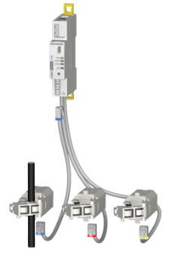 | - Be an integral part of the power monitoring system and shall come from the same supplier as the measurement modules.  - Have an mV output and an RJ type connection to the current module.  - Allow a risk-free connection and disconnection under load  - Eliminate the risk of error during installation, thanks to an automatic detection of the circuit type, the rating of the current sensor and the direction of the current flow.  If an installation error is detected during commissioning, an alarm will be automatically generated.

The power monitoring system shall adapt to any type of new or existing electrical installation by choosing from the following current sensors:

- Solid-core TE, 5 A to 2000 A
  - The solid-core current sensors shall be mountable in line or staggered to always match the pitch of the protective device
  - The power monitoring system and current sensors do not need to be calibrated.

- Split-core TR, 25 A to 600 A
  - The split-core current sensors shall be mountable in line or staggered to always match the pitch of the protective device
  - The measurement system and current sensors do not need to be calibrated.

- Split-core iTR, 25 A to 600 A embed a feature to detect voltage in conductors
  - The split-core current sensors shall be mountable in line or staggered to always match the pitch of the protective device
  - The current sensors shall also offer advanced technologies based on a voltage detection of conductors enabling to:
- Monitor the upstream protective device (ON/OFF position, tripping, operation and trip counters) without the use of auxiliary contacts. This function will be compatible with any brand and any type of protective device.
- Provide a software correction of wiring errors, even off-load
  - The power monitoring system and current sensors do not need to be calibrated.

- Flexible TF, 150 A to 6000 A.
  - The power monitoring system and current sensors do not need to be calibrated.
  - The flexible sensor must have a locking system that prevents the loop from opening inadvertently.

  - Residual Current Transformers

Residual CTs shall:

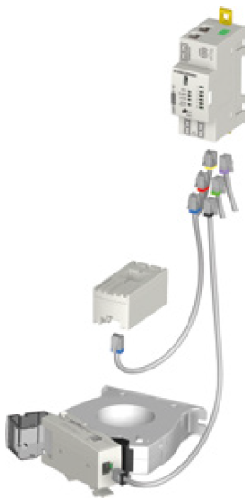 | - Be an integral part of the monitoring system and shall come from the same supplier  - Be minimum Type A according to IEC 62020  - Have an RJ type connection to the current module.  - Include an alarm indication LED to easily locate alarms inside electrical panels  - Allow a risk-free connection and disconnection under load

The measurement system shall adapt to any type of new or existing electrical installation by choosing from the following residual CTs:

- Solid-core ΔIC residual CTs
  - Apertures from ø 8mm up to ø 300m
  - Centering accessory to ensure accurate measurement and enhanced immunity to network interferences.
  - Multiple mounting options: DIN rail, back plate, direct mounting onto the cable

- Split-core ΔIP-R residual CTs
  - Apertures of ø 80mm and ø 120mm
  - Centering accessory to ensure accurate measurement and enhanced immunity to network interferences.
  - Multiple mounting options: DIN rail, back plate, direct mounting onto the cable

  - Bluetooth sensors

Environmental Bluetooth sensors shall:

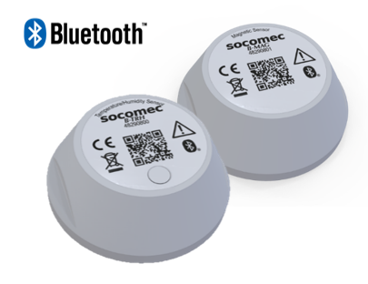 | - Be an integral part of the monitoring system and shall come from the same supplier  - Be integrated using mounting accessories to facilitate installation  - Be detected and associated with DIRIS Digiware D-50 Bluetooth, D-70 Bluetooth, M-50 Bluetooth & M-70 Bluetooth communication gateways  - Be readable on the D-50 Bluetooth and D-70 Bluetooth displays (real time values) and Webview (real time values and historical values) on the D-70 Bluetooth and M-70 Bluetooth communication gateways  - Allow access to data via communication gateways in Modbus TCP

The measurement system must be compatible with any type of new or existing electrical installation thanks to the following Bluetooth sensors:

- Bluetooth temperature + humidity sensors B-TRH
  - Integrates temperature and humidity data into the Digiware measurement system
  - Sending real-time alerts when the measured temperature or humidity exceeds a predetermined threshold
  - Several mounting options: mounting accessory with screws or with a double-sided sticker.

- Bluetooth sensor magnetic contact B-MAG
  - Detects loss of magnetic contact
  - Send real-time alerts when a door is opened
  - Several mounting options: mounting accessory with screws or with a double-sided sticker, adapter plate for universal integration into any electrical cabinet

  - DIRIS Digiware IO: input/output modules

- DIRIS Digiware IO-10: digital input/output module
The digital input/output modules shall have at least 4 inputs and 2 outputs, to:
- Count pulses from multi-utility pulse based meters (water, gas, etc.)
- Monitor protective devices (ON/OFF position, tripping, trip counter) or the status of third-party devices.
- Control third-party equipment
- Trigger load shedding commands in case of an alarm on another DIRIS Digiware module

- DIRIS Digiware IO-20: analogue input modules
The analogue input modules will have at least 2 x 0/4-20mA inputs, to:
- Collect data from analogue sensors, such as pressure, humidity, temperature, levels (fuel, etc.)
- Monitor levels by setting up threshold alarms

- Configuration

The measurement system can be configured from the remote display or from a free dedicated configuration software downloaded on a PC with a USB, RS485 or Ethernet connection.

The measurement system shall also enable:

- Automatic detection and addressing
An auto-discovery and auto-addressing function can be launched from displays and gateways to automatically detect connected slave devices and assign them with a unique Modbus address.

- Software correction (with iTR sensors)
iTR current sensors shall embed a wiring error correction technology, based on a voltage detection of conductors. This technology shall also work off-load.

- Commissioning

The manufacture shall propose commissioning services for the power monitoring system and visualisation software.

